MZUMBE UNIVERSITY

FACULTY OF SCIENCE AND TECHNOLOGY (FST)
COMPUTING SCIENCE STUDIES DEPARTMENT (CSS)

PRACTICAL TRAINING REPORT

NAME OF STUDENT: FRANK P MSISI
REGISTRATION NUMBER: 14320040/T.20
E-MAIL: msisifrank88@gmail.com
PHONE NO.: +255 712 803 433
YEAR OF TRAINING: 2021/2022
PROGRAMME: BSc. ITS- 2
ORGANIZATION NAME: DAR ES SALAAM CITY COUNCIL
NAME OF FIELD SUPERVISOR: MR. CHARLES MACHANGE
MU SUPERVISOR: DR. MERCY

COPYRIGHT
I hereby declare that the report has been prepared by myself to fulfill the curricular requirement of Bachelor of Science degree in Information Technology and System (BSc.ITS) offered by Faculty of science and technology at Mzumbe University. It is illegal for a person to photocopy or copy any kind of piece of paper from this report without permission of the owner.
© Frank P Msisi

2022

DECLARATION
I am Frank P Msisi, I declare that this fieldwork report together with Student’s logbook attached at the end of this report contains my own original work performed to the very best of my knowledge and understanding except for information obtained in a legitimate way from literature and an organization as a whole. All information from these other sources has been duly referenced and acknowledged.
Signature: ________________
Date: _____/_____/_______

ACKNOWLEDGEMENT
The accomplishment of this field has been made possible through the effort and assistance received from numbers of people. Thus, the satisfaction that accompanies the successful completion of any task would be incomplete without mentioning of people whose ceaseless cooperation made possible, whose constant guidance and encouragement crown all efforts with success.
My highest gratitude to almighty God for granting me the will and strength and enable me to attend and finish my field and till the end of completion of this report. Without His consensus, this field and its report could not have been completed. In particular, my deepest thanks are to my supervisor Mr. Charles Machange and MU supervisor Dr. Mercy for the guidance, inspiration and constructive suggestions that assisted in the preparation of this report.
My lastly gratitude goes to my friends and my family, whom I am blessed to have, for their support during the field period and writing this report.

ABBREVIATIONS AND ACRONYMS
BIOS Basic INPUT/OUTPUT System
CSS Computing Science Studies
DC Domain Controller
DHCP Dynamic Host Configuration Protocol
DNS Domain Name Server
DRS Daily Report System
ICT Information Communication Technology
IT Information Technology
MU Mzumbe University
OS Operating System
PC Personal Computer
RAM Random Access Memory
RJ-45 Registered Jack-45
UPS Un-Interrupted Power Supply
USB Universal Serial Bus

EXECUTIVE SUMMARY
This is my practical training report as it was conducted at Dar es salaam city council under Department of Information and Communication Technology from August 08th to September 30th 2022. This report is divided in three main sections of hardware, software and networking.
In the hardware section the following was mastered and is reported in here, these are familiarizing oneself with working equipment, adapter fixing which consist of approach of fixing adapters, testing adapter capacitors, checking input and output ac, checking output cable and measure of fuse on adapter. Photocopy machine fixing which consists of checking connection of cables, opening the machine to check drum unit and fuser unit and cleaning of the scanner. Laptop fixing where skills acquired are in changing laptop display, replacing of keyboard, fixing blue screen error, fixing error of not working USB ports and not responding mouse.
In the software section the skills I mastered is installation of operating system and Microsoft office and other application software such as windows, adobe reader, avast anti-virus etc.

ABSTRACT
This report entails the description of the major activities, tasks and skills that I learnt during my field practical Training which I conducted for about 8 weeks from August 08th to September 30th for making into practice what I have been learning at the University and acquire new experience from the Dar es salaam city council.
Thankfully, there are more of unprecedented experiences on the Computer Technology, which I acquired at the organization. I have tried to analyze all the activities, Skills and knowledge attained on the course of this Practical Training in three subdivisions: - Hardware Maintenance, Software Installation, Maintenance, and Networking.
However, in networking part I grasp experience on Crimping of network cables (UTP cables), D-link Wi-Fi Access point Configuration, Printer Sharing and Basic Network Troubleshooting Techniques.

TABLES OF CONTENTS
COPYRIGHT i
DECLARATION ii
ACKNOWLEDGEMENT iii
ABBREVIATIONS AND ACRONYMS iv
EXECUTIVE SUMMARY v
ABSTRACT vi
TABLES OF CONTENTS vii
LIST OF FIGURES ix
CHAPTER ONE 1
INTRODUCTION 1
1.0 Introduction 1
1.1 Dar es Salaam City Council Background 1
1.2 Primary Function of Dar es Salaam City Council 3
1.3 Review of the Sector 4
CHAPTER TWO 5
DUTIES UNDERTAKEN 5
2.0 Introduction 5
2.1 Replacement of Hard drives PC 5
2.2 Disk formatting, partitioning and replacing 6
2.3 Cables and Connectors of hard disk 8
2. 4 Crimping of the UTP Cables 9
2. 5 Network Connection Troubleshooting (Wireless/LAN) 10
2.6 Installation of Operating Systems (Linux mint) 11
2.6.1 Upgrade of Application Programs (Microsoft Office 2016) 14
2.8 Computer Networking 14
2.8.1 DNS 15
2.8.2 Creating the DHCP server 15
2.8.3 Network security 15
2.8.4 Network SSID 15
2.9 Installation of Kaspersky antivirus 16
2.10 Daily Report System (DRS) 18
2.11 Lesson learnt 21
CHAPTER THREE 23
INTERPRETATION AND ANALYSIS 23
3.1 Improvement of the Existing Skills 23
3.2 New Skills Learnt 23
CHAPTER FOUR 24
GAPS IN SKILLS AND TECHNOL0OGIES 24
4.1 Gaps in Skills 24
4.2 Challenge 24
CHAPTER FIVE 26
CONCLUSIONS AND RECOMMENDATIONS 26
5.1 Conclusion 26
5.2 Recommendation 26
REFERENCES 28

LIST OF FIGURES
Figure 1.1 Dar es salaam city council and other District in Dar es salaam Region 3
Figure 2.1 Appearance of a hard disk 6
Figure 2.2 Cables and connectors of HDD (Hard Disk Drive) 8
Figure 2.3 Showing crimping of UTP cable 10
Figure 2.4 Different connection configuration of Crossover 10
Step 2.5 Create a live USB of Linux Mint 12
Figure 2.6 Shows Upgrading of Microsoft Office 14

CHAPTER ONE

INTRODUCTION

1.0 Introduction
A Field Report is set as assignment in a variety of disciplines and usually requires the student to combine theory and analysis with observation and practice.
This type of report is intended to improve student understanding of key theoretical concepts of a course through observation and reflection about real life practice. In addition, this type of report facilitates the development of data collection and observation skills and allows students to see how theory applies to real world practice. The function of field reports is to describe an observed person, place or event and to analyze that observation. The student will develop a professional identity as a social worker that is characterized by competence in a broad range of social work skills, knowledge and values.
Overall, this chapter explains different things that are done at DAR ES SALAAM CITY COUNCIL.

1.1 Dar es Salaam City Council Background
The city of Dar es Salaam is located between Latitude 6 to 7 degrees Celsius and 39.45 degrees Celsius on the East and 39 degrees on the West, South Equator and West, South and North. The city is bordered by the Coast Province, to the east by the Indian Ocean, where there is a coastline of km. 124 from Pemba Mnazi to Mbweni.
The city of Dar es Salaam has an area of ​​about 1,800 square kilometers; of these, 1,350 square kilometers is the land area comprising eight islands in the Indian Ocean area and 450 square kilometers is the seawater. Dar es Salaam City area is equivalent to 0.2 percent of the country area which is 881,289 square kilometers.

Weather
The city has a tropical coastal climate, with an average temperature of 25 to 33 degrees Celsius and an average rainfall of 1,000 milliliters in the two autumn seasons which are October - December and the spring which begins in March - May. The city is often dominated by winds blowing from the sea from the South, East and North of the Indian Ocean.

Population
According to the 2012 census the city has a population of 4,364,541, of whom 2,125,786 are males and 2,238,755 are females. In addition, the population has grown by an average of 5.6 percent per year. The average population per square kilometer was 3,137 and the average household size is 4 people per household. With this annual increase, the City of Dar es Salaam in 2018 is estimated to have a population of 6,107,473. This population is increasing the population density of an estimated 4,383 people per square mile.

History of City Council
Dar es Salaam City Council has been in charge of the City from 1961 to 1972, when the Government of the United Republic of Tanzania dissolved all Councils in the country and came under the control of the Central Government (Regional Powers).
The Central Government repatriated Local Governments, Under Local Government (Urban Authorities) Act and. 8 of 1982, where the City Council began fulfilling its responsibilities of providing services to citizens from 1983.
In 1996 the Central Government dissolved the City Council and formed the Dar es Salaam City Commission, by Government Proclamation no. 110 and 111 dated June 28, 1996.
The City Commission operated for a period of four years, during which in 2000 the Government created four Dar es Salaam Regional Local Government Authorities under the Local Government (Urban Authorities) Act no. 8 of 1982, as amended by law and. 6 of 1999.

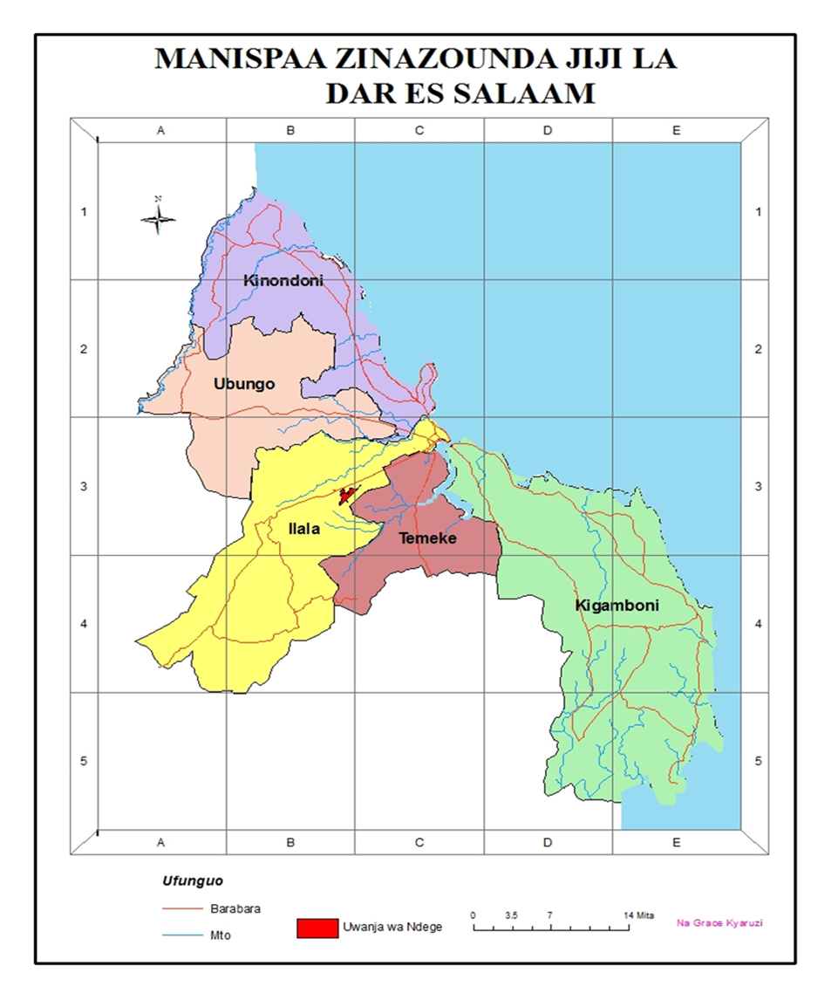

Figure 1.1 Dar es salaam city council and other District in Dar es salaam Region

1.2 Primary Function of Dar es Salaam City Council
- Develop, implement and monitor its strategic plans and budgets
- Plan for and provide services and facilities for the local community.
- Raise revenue to enable the district council to perform its functions
- Develop, implement and monitor its corporate and financial management control techniques.
- Establish norms and standards in the conduct of its affairs.
- Perform and discharge the functions and exercise the powers under this act or any other enactment relating to local authorities.
- Do such things as are incidental or conducive to the performance of any of its functions under the Act.

1.3 Review of the Sector
Dar es salaam city council works on different sector such as
- Services improved and HIV/AIDS infections reduced and health service provision

- Enhance, sustain and effective implementation of the National Anti-Corruption Strategy
- Access and quality social services improved
- Quantity and quality of economic services and infrastructure improved
- Management of natural resources and environment improved
- Emergence preparedness and disaster management improved
- Social welfare, gender and community empowerment improved
- Good governance and administrative services enhanced

CHAPTER TWO

DUTIES UNDERTAKEN

2.0 Introduction
Kindly, there are several tasks which I was assigned during the whole course of my Practical Training at Dar es salaam city council ICT Unit; here is the brief description on the activities I took and the new experiences I grasped on the whole tenure; -

2.1 Replacement of Hard drives PC

Some of the Computer Systems within the organization needed replacement of hard drives due to multi-functioning or small memory capacity of the Drive. I participated on the tasks to replace the HDD, here are the guidelines used;
- Unplug the power cable and with the power cable removed press the Power button on the front of the computer (to release any), assuming all other cables are removed earlier. Thereafter, Remove the screws on the rear (back end) of the computer and Slide both side panels off from the rear of the computer.
However, on some cases, it might be necessary to remove the front of the computer so that you can remove the drive cage. If so, press in on the tabs that retain the front cover, there should three to four on each side of the cover and gently pull forward. It helps to have a friend help with this process. Carefully detach any cables that are also attached to the front cover.
- On many HP and Compaq computers, drives are attached to drive cages. Often, the installation and removal instruction for the cages are located next to the drive cage or on the side panel.
- Removing the drive: If the drive is attached to the chassis or drive cage with screws, remove the screws and plastic latch you will need to insert the screws into the drive and screw them down before sliding the drive into place.
- Replacing the cover(s):If the front cover was removed earlier, connect any cables that go to the front cover, align the tabs on the front cover to the holes in the front of the chassis and snap the front cover into place. Fasten the screws to secure the side panel. Repeat for the other panel.

- Assemble a PC
– Install a Power Supply
– Install a LAN Card
– Connect the IDE Cable
– Set the Jumper
– Install the Hard Disk
– Complete instillation

2.2 Disk formatting, partitioning and replacing
A hard disk drive is nonvolatile data storage component of the PC
Hard disks are implemented using disk shaped platters made of aluminum or glass

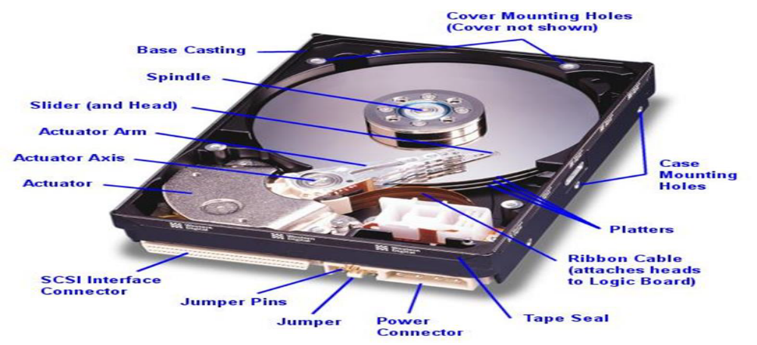

Figure 2.1 Appearance of a hard disk

Disk formatting
• At machine level, the hard disk is formatted using demarcations of tracks and sectors
• A sector on the hard disk contains storage size of 512 bytes.
• This forms the smallest addressable block where a file can be stored.
The boot sector
• A part of the hard is called “Boot sector”.
• The Boot sector is:
– Always the first sector (sector 0) of the first track (track 0) of the first cylinder (cylinder 0) disk.
– 512 bytes long just like any other sector
– Contains information on all logical drives, regardless of whether they are bootable.

Disk partitioning
- Partitioning a disk is the act of defining areas of the disk for an operating system to use.
- Partitioning is required because a hard disk is designed to support different types of file systems.
- Partitioning enables a single hard disk drive to run more than one type of operating system (dual boot), or it can enable a single operating system to use the disk as several volumes or logical drives with different file systems.
- You decide you want to break the 10GB space into three logical partitions: one with 5GB of space, one with 3GB, and one with 2GB.
- The operating systems will logically view these three partitions as three separate drives and gives them separate drive letters C: D: and E:
- Physically all you have is one hard drive with three logical drives.
- Hard drive partitions must always begin at C: because the A: and B: drives are reserved for floppies.

2.3 Cables and Connectors of hard disk
- Hard disk drives typically have several connectors for interfacing to the computer, receiving power, and sometimes grounding to the system chassis. Most drives have at least these three types of connectors:
-Interface connector(s)
-Power connector
-Power connector
-Optional ground connector
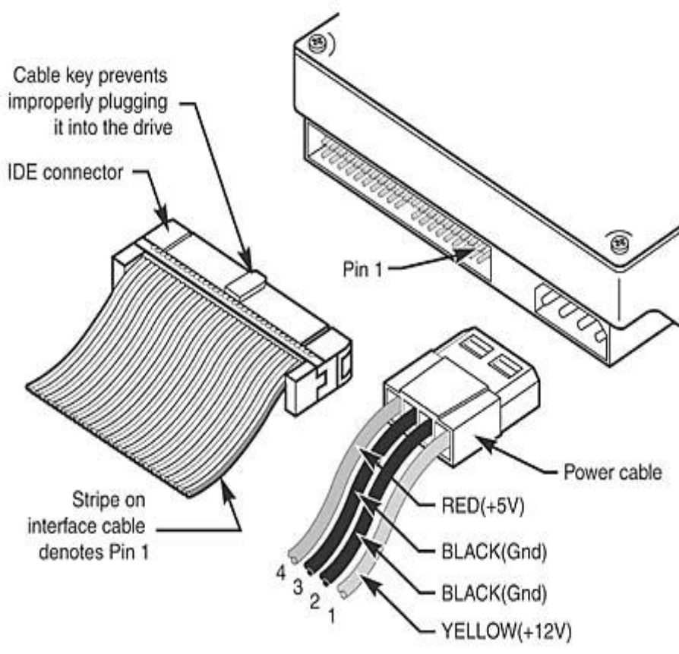

Figure 2.2 Cables and connectors of HDD (Hard Disk Drive)

Printer Fixing Issues
While on my Field Training at the Dar es salaam city council, I developed an understanding on Troubleshooting Printer (HP laser Jet Pro 400 M401d) minor issues like Paper Jam fixing, replacement of the Cartridges, replacement of the roller, rebooting; they were done through the following respective procedures; -
- Paper Jam fixing
Paper Jam is the situation where the paper stacks on while printing causing the printing to stop; to troubleshoot this issue you have to undertake several steps; -
- If you can see the jammed sheet, remove the jammed sheet by pulling it straight out. If you cannot see the jammed sheet, open the print cartridge door, and then remove the print cartridge. Do not pull upon the jammed sheet. Be sure to pull it straight out.
- Reinstall the print cartridge, and then close the print cartridge door. Remove all the tiny papers remaining if any.
- Slide the drive out. If the drive is retained by a plastic latching system, lift the latch to slide the drive out.
- Installing a new drive: Slide the new drive into the open bay until the screw holes align with the holes in the chassis or drive cage. If the drive attaches to the chassis using a

2. 4 Crimping of the UTP Cables
This task required me to make proper Straight-through (unlike devices) and Crossover (like devices) cables from an Unshielded Twisted Pair (UTP) cable and then joined by the two ends with the RJ-45connector by using crimping tools. Actually, for Straight-through (connecting devices like; Computer to switch, a router`s WAN port to a cable/DSL modem`s LAN port) the color codes for both ends are: white-orange ,orange, white-green, blue, white-blue, green, white-brown, brown; while for Cross-over it has different color codes in both ends. The photograph below shows the UTP cable and Crimping tool.
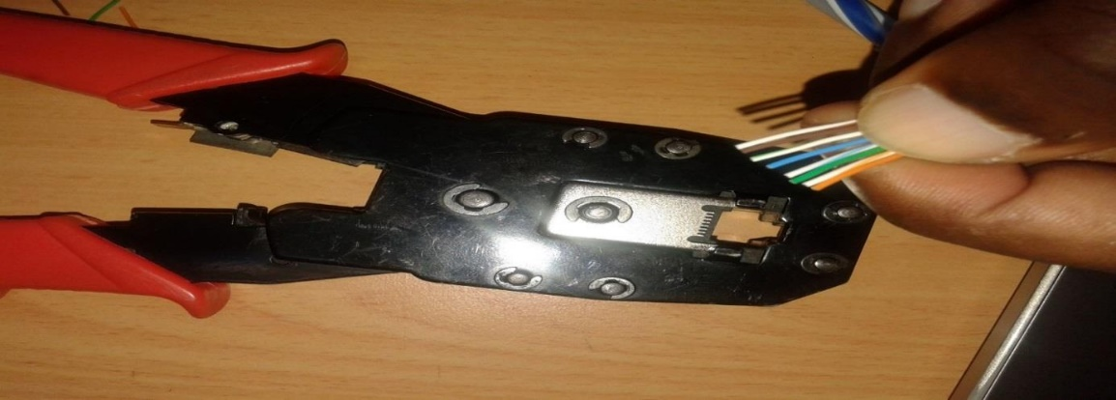

Figure 2.3 Showing crimping of UTP cable
Uniform manner to make a perfect UTP cable by checking wires are flat against the front of the plug before punching the cable with a crimping tool.
In line with that, I learnt how a crossover cable could be made in two different techniques but offer a same working. As illustrated below with diagram i and ii.
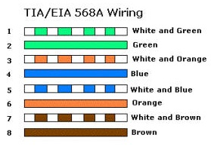

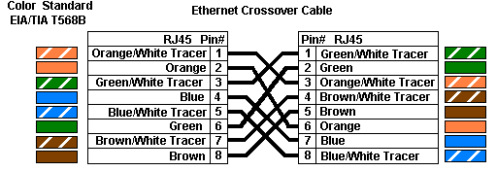

Figure 2.4 Different connection configuration of Crossover

2. 5 Network Connection Troubleshooting (Wireless/LAN)
During my training, I learn how to fix connectivity errors, computer errors, LAN connectivity issues; this was the task I had to undertake daily after signing the Attendance book. Whether your operating system is Windows are likely to arise. Many times the network problems at Dar es Salaam city council arise due to improperly/unplugged network cable connection.

The following are the basic checklist to identify and troubleshoot the basic networking errors I learnt.
- First, you should learn what stopped working server or client computer also see if the outage affecting the other computers or only one.
- If your server stopped working, you should inform the users of the server and you should start working on fixing the error.
- If a single client computer stopped working or disconnected from the network, ask the user of that computer that what recent changes cause the computer to stop working such as newly installed software or games, service packs, internet software, new hardware or any other thing.
- Check the physical network connectivity. The most network problems arise due to the physical layers’ failure.
- Check all the network cable connections. You can start at the NIC and check if the green light is blinking then check the hub and see if the computer is getting the link across the cable.

2.6 Installation of Operating Systems (Linux mint)
The following is the step that I follow during the installation of linux mint.
Step 1: Download Linux Mint ISO
Go to Linux Mint website and download Linux Mint in ISO format. This file is used for creating the installation USB.
If you do not know about them, go with the default Cinnamon edition. When you click on that, you’ll find various mirror websites and torrent link to download the ISO file.
If you have a good internet connection for downloading 2 GB of file without any issue, use a mirror which is closer to your country of residence (for faster download).
If you do not have a good consistent internet connection, opt for the torrent version (if you know what torrent is).
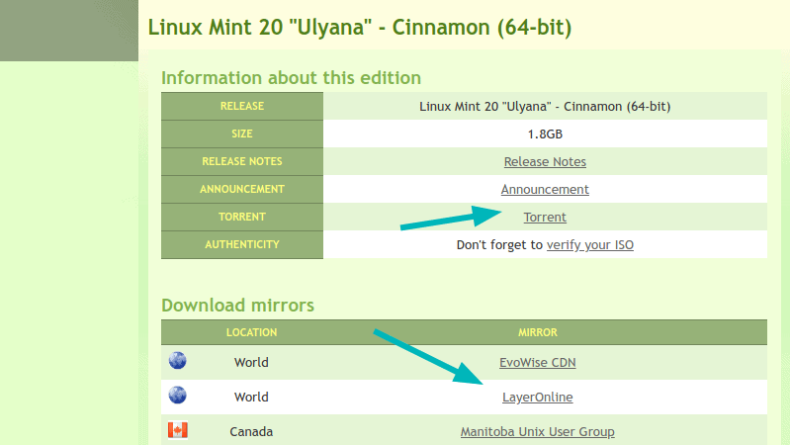

Step 2.5 Create a live USB of Linux Mint

Now that you have downloaded the ISO, it is time for creating a live USB of Linux Mint.
If you are using Windows, you can also use Rufus. In the example here, I have used Rufus.
Download Rufus and run the .exe file and you’ll see a screen like the below image.

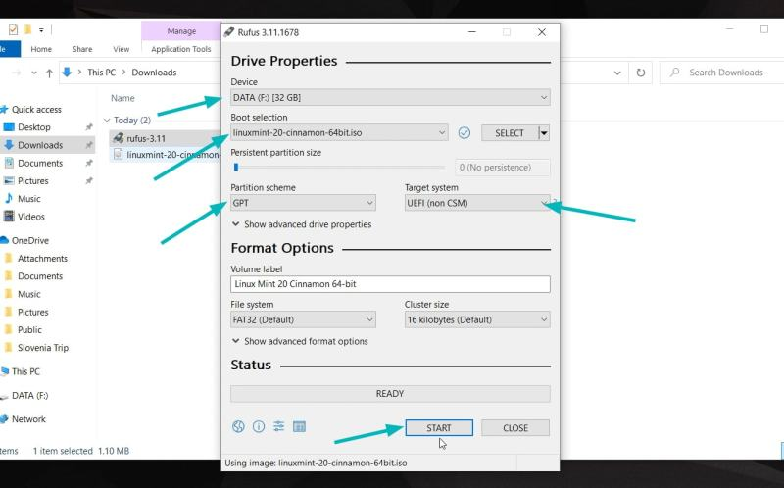

You select the ISO. You may confuse over the partitioning scheme. Almost all the computers in last 7 years or so use GPT partitioning scheme. Older computers may use the MBR partitioning. You should check which partitioning scheme your system uses to be sure.

Step 3: Boot from the live Linux Mint USB
Once you have successfully created the Linux Mint USB, it is time to use it for installing the awesome Linux Mint.
Plug in the live USB of Linux Mint and restart your system. At the boot screen when you see the logo of your computer manufacturer, press F2 or F10 or F12 to enter the BIOS settings.
In here, you should make sure that booting for USB or removable media is on the top of the boot order.
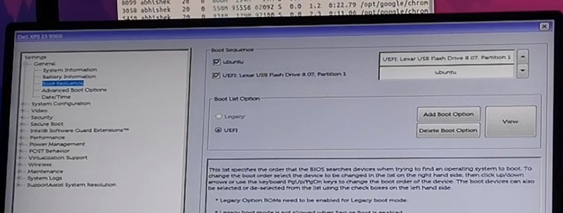
Move the USB on the top of the boot order
This screen may look different for different manufacturers. You’ll have to find this setting on your own or search the internet.
Make the changes, save and exit.

Step 4: Install Linux Mint
Now you should boot into the live Linux Mint environment. You’ll see a screen like this that gives you a couple of options. Go with the first option.
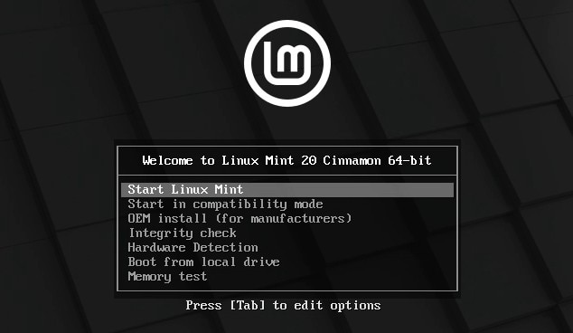
In a few seconds you’ll be inside the Linux Mint live environment. It may take more time if you have USB 2.
You’ll see a “Install Linux Mint” icon on the desktop. Click on it to start the installation procedure.

It will ask you to choose some basic configurations like language and keyboard layout. Choose the most appropriate ones for your system.

2.6.1 Upgrade of Application Programs (Microsoft Office 2016)
I upgrade Microsoft office software from office 2010 to office 2016 of different offices at dar es salaam city council. This was done by the following guidelines:
- Insert flash driver Office 2016 into flash port, open My Computer, run the program as the administrator, enter the 25-character product key printed on your Office 2016 product box, then continue button, and check I accept the License terms.
- When you see the main installation screen, hit the Upgrade button and you are done. This will remove all previous versions of Office 2010 and replace them with Office 2016.


Figure 2.6 Shows Upgrading of Microsoft Office

2.8 Computer Networking
During my practical training, I also participated in computer networking activities. Under this part of training, I participated in the following duties:
- Wired network installation and troubleshooting
Under this part is participated in installing the wired network using RJ – 45.
Rj-45 is the cable that is used to connect the wires transmitting the to the router/switch or computer device. That composes of eight pins in which each pin is connected to one wire.

- Wireless network installation and troubleshooting
Under this part, I participated in the installation of the wireless network for personal computers (PC). This included the process of configuring wireless in computer and linking the computer to the wireless service.
The process includes
- Open the network and sharing Centre
- Click on setup a new connection or network
- Enter the name of the network and the security password, note that the security password strength differs according to the security type you have chosen
- Check the save this network checkbox and click finish.
- Select the network connections at the taskbar and select your then network you prefer and then connect.

2.8.1 DNS
This is found by clicking on the IP then DNS there after you inter the IP address of the server, which you want to link with your devices.

2.8.2 Creating the DHCP server
Create the Dynamic Host Configuration Protocol (DHCP) server by click on the IP then DHCP server then DHCP setup. This must have a check mark placed in the selector box to activate it, and this is necessary when providing Internet access to the public. DHCP communicates with a user's computer and assigns an IP address to each computer connected to the local network, so that Internet traffic may be routed to each computer as needed.

2.8.3 Network security
For a more secure network where only your customers are able to access the network, create a WPA2 key and write down the hexadecimal code of that key to give to your customers. Customers will be prompted by their computers to enter the key when trying to connect to your network, and will have access once the key has been entered. This key also encrypts the Internet traffic between the customer's computer and your access point for even more security.

2.8.4 Network SSID
In addition, you should give wireless identity so that to be easier for customer to know it has wireless.
Also, the firewall should be removed so that to be able to log in the radio or router when you are out the range of that device.

2.9 Installation of Kaspersky antivirus

Steps to install Kaspersky Anti-Virus
- Check your computer meets the system requirements for Kaspersky Anti-Virus.
- Check whether any applications installed on your computer are incompatible with Kaspersky Anti-Virus. We recommend removing all incompatible software to ensure that Kaspersky Anti-Virus works correctly.
- Close all running applications
- Download the Kaspersky Anti-Virus installation package.
- Run the installer.
- Wait until the searching for a newer version of the application has been completed, or click Skip.
- Read the End User License Agreement and click Continue if you agree to the terms.
- Read the Kaspersky Security Network Statement carefully. Select the checkbox if you agree to the terms.
If you don’t want to participate in the Kaspersky Security Network, clear the checkbox.
- Together with Kaspersky Internet Security, Kaspersky Secure Connection will be installed to ensure protected connection to the Internet. Click Install.
- Wait for the installation to complete. Make sure the recommended settings are enabled and click Apply.
- Click Done.
Kaspersky Anti-Virus will now be installed
To activate the application:
- In the application window, click.
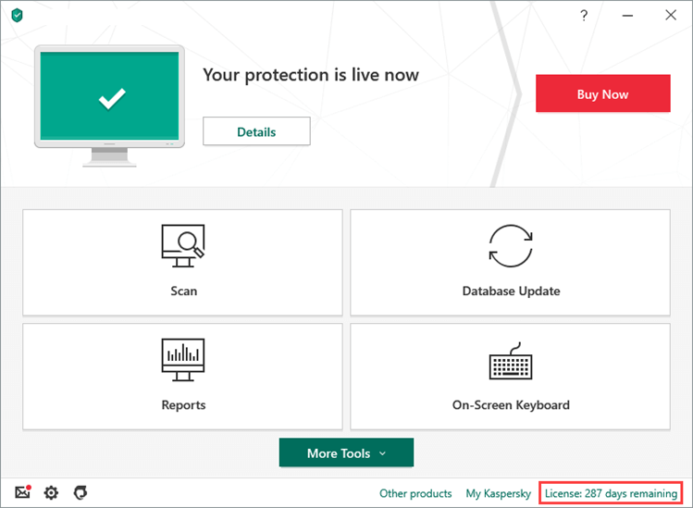
- Click Enter activation code.
- Enter the code from the message you have received after buying the license and click Activate.
- Click Done.
Kaspersky Anti-Virus is now activated.

2.5 configuration of NanoStation
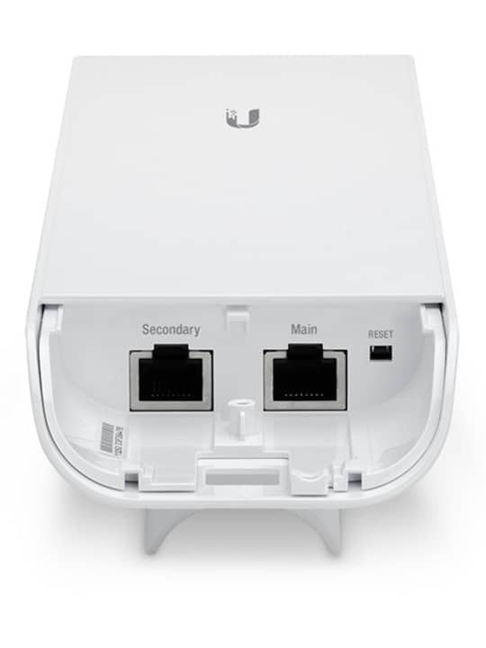
The Secondary Ethernet Port is included on only the NanoStation M2/M3/M5. It is capable of 24V
Power over Ethernet output, which can provide power to a secondary device. It can be enabled using the airOS Configuration Interface.
Accessing airOS
Connect to the airOS Configuration Interface.
1. Make sure that your host machine is connected to the LAN that is connected to the Ubiquiti device.
2. Configure the Ethernet adapter on your host system with a static IP address on the 192.168.1.x subnet.
3. Launch your web browser. Type https://192.168.1.20 in the address field and press enter (PC).

2.10 Daily Report System (DRS)
The system is general used to display advertisement to the user for different companies registered in the system, then after a while
At first time to start to create pages of system, Background of Pages and Edit name of website that to suggest as Daily Report System
This system designed for the purpose of sharing information from different facility to head of department this activities done through the internet in system.
Tools needed to perform the task include;
- Web browser. Example Opera
- Text editor. Example visual studio.
- Image manipulation software.
- Xampp (Mysql)
I use markup language in designing this system as well as styling sheet and some sort of JavaScript as a programming language of markup language I use.
Frontend language:
- Hypertext Markup Language (HTML)
And the styling sheet was
- Cascading Styling Sheet (CSS)
Backend Language:
- Hypertext Preprocessor (PHP)
- Java Script (JS)

The system have two panel
- Client side / assistant nurse
- Head of department of health in Dar es salaam city councilor
Sample of picture that I snap after development DRS
- On that page head of department can add another facility on the system.
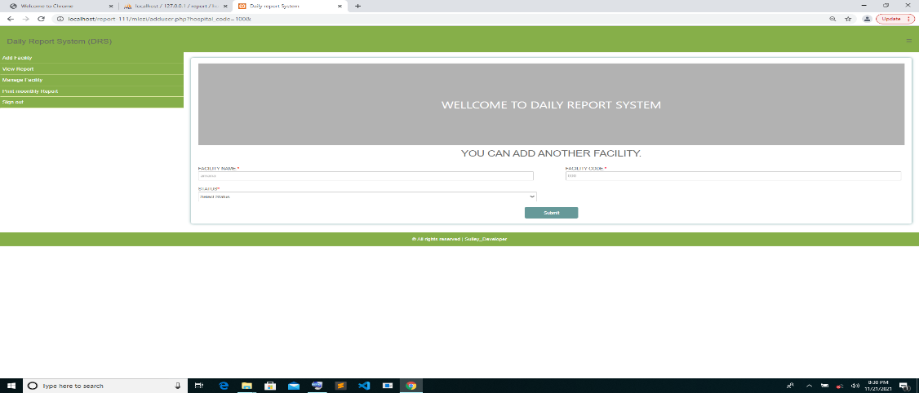

- On that page head of department he/she can see the facility that he/she added on the system.
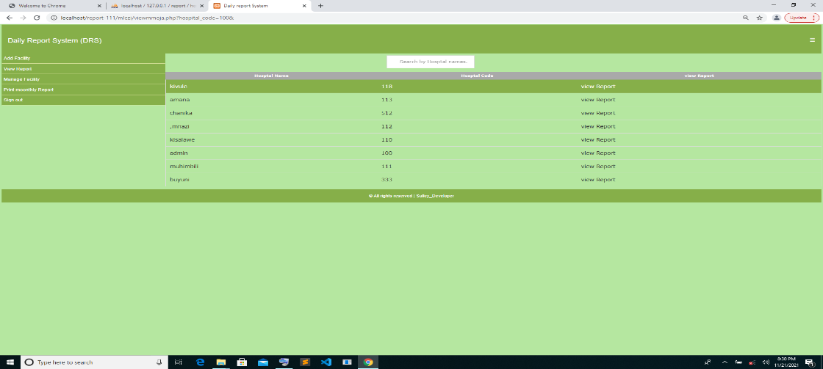
- On that page head of department he/she can see and print individual report as you see above after selected facility
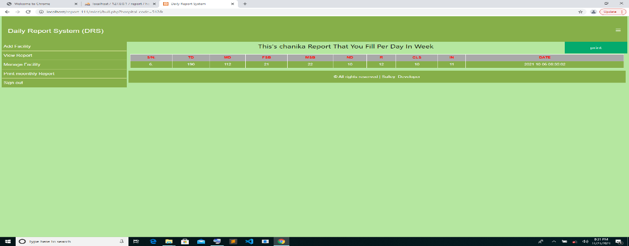

- On that page assistant nurse he/she must fill field input and he/she submit to head of department in Dar es salaam city councilor
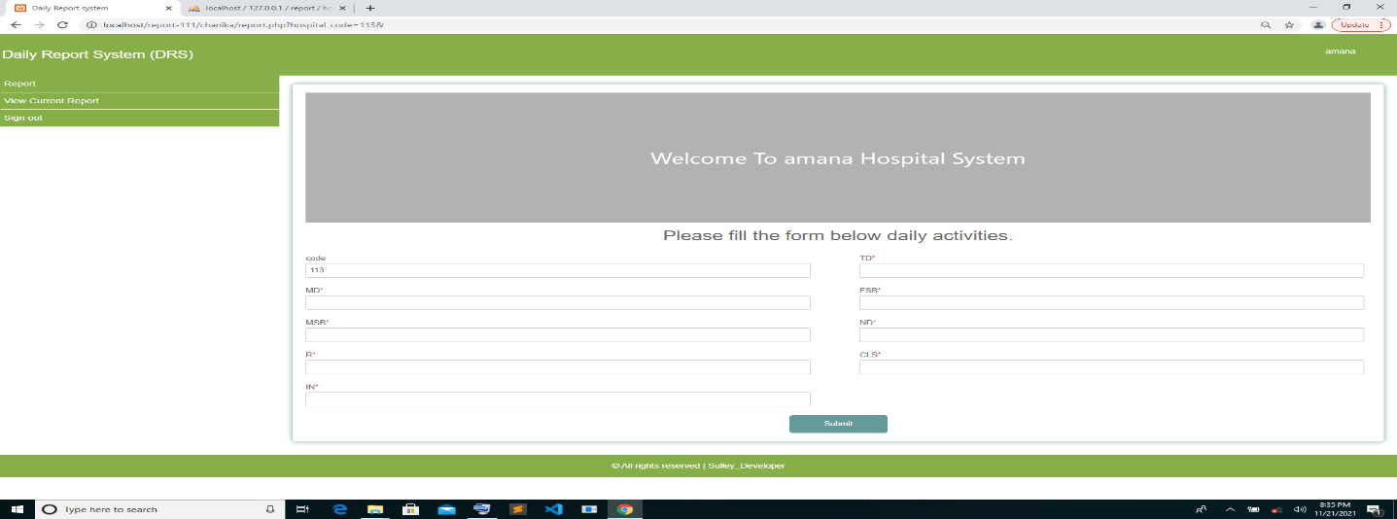
- On that page nurse he/she can view report that submitted. He/she can see current submitted report only.
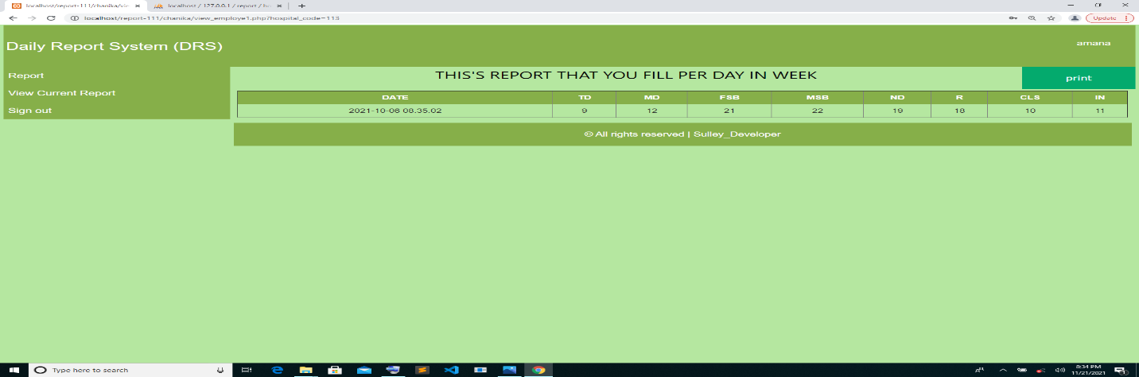

2.11 Lesson learnt
Due to the tasks I performed, the help I got and the duties I completed, I can say that my fieldwork training was successive and I completed it successively attaining what I want. I can say that I full filled my desire on computer maintenance and repair as well as computer networking. The following are the lessons learnt from the practical training.
I learned how to fix paper jams and the causes of it and proper ways to avoid Jamming while Printing together with possible areas where jams appear. The following are the ways to reduce paper jams: -
- Use only paper that meets HP specifications for this product and never use paper that has previously been printed or copied on.
- Use paper that is not wrinkled, folded, or damaged. If necessary, use paper from a different package.
Also, I learnt how to install linux mint operating system in different manner from what I normally used to do.; it is not the case, I noticed some of these updates (Security Patches) help to protect the system from being attacked by virus which normally are associated with the files we save and download from the internet by fixing the vulnerabilities and errors in linux mint and associated software, and they occasionally add new features.

CHAPTER THREE

INTERPRETATION AND ANALYSIS

3.1 Improvement of the Existing Skills
Most of the things, which we are practicing in our fieldwork, are not taught in the class. In our class we learn theoretical things and the same things seem to be new when we come to practical training. New thing emerges while we are practicing. Things such as mobile service via web browsers, computer hardware problems and some network problems. This makes the huge difference between the practices and the theory. Therefore, through this practical training I have learn and improve my theoretical concepts into more practical one so as to be competent and
Fieldwork has highly motivated me as far as my career in such a way that most of work I attended made me to go in deep in computing environment as the needs of information technology knowledge was being an issue to most workers of different professions. I had been improving my computer knowledge since I attended practical, for example some session on computers I used to do with command prompt unlike earlier where I saw commands as new thing to me now being the normal thing as I had practicing during the field training. Also in networking, I understood how to connect network wire by using RJ-45, connection of wireless network and network troubleshooting. I got more knowledge and became comfortable of these techniques and activities

3.2 New Skills Learnt
I also learn graphics design using adobe Photoshop to design different advertisement about district councils for instances seminars advertisement, motivation advertisement and so on
In brief, networking was very interesting lesson that I learnt in that place. Most of networking activities are very exciting, for example to connect network wires by using RJ-45, to connect wireless network and network troubleshooting. Also, computer maintenances, in computer maintenances the minor tasks such as troubleshooting parts within the motherboards became exciting activities after I had been guided to accomplish that task. Also in installation processes, I got different techniques rather than those I have before on this process. For example, in operating system installation process the issue of memory storage, partition by using New File Technology System (NFTS) was important than most of the think about.

CHAPTER FOUR

GAPS IN SKILLS AND TECHNOLOGIES

4.1 Gaps in Skills
The tasks like those of operating on servers, students especially those of practical training were not allowed to interact with, reasons behind are confidentiality of information contained on servers. And in turn, the server’s issues are learned in classes as theories so most of students up to their completion of studies may lack practical experiences on servers otherwise they will search themselves in private cases as special courses. Another skill that student in practical cases may lack are those of system development, this is due to fact that most of the time during field training the organization has complete system and systems are running well, that means no maintenance needed. Also issues such as database development in most cases was assigned to different department such as accounting and human resources management

4.2 Challenge
- Absence of blower for removing dusts from computer hardware
This problem was dominant at High view school, I solved this by using an alternative blower, which was open fan, and I also used a dry piece of cloth and soft brush. I also recommended for blower to be bought.
- Lack LAN testers for testing whether UTP cable is working or not.
This was another problem but I was solved by recommending for it and it was bought.
- Lack of computer hardware such as Hard Disk, RAM, and DVD-ROM in case whether we need to upgrade RAM or HDD (Hard Disk Drive).
This computer hardware was, bought and replaced whenever they were needed.
- Some of the workers were not participating fully when their participation is needed especially when they are asked to stop doing their activities and give space to ICT peoples to do the maintenance or troubleshooting.
This was solved by explaining to them the importance of maintenance we want to conduct.
- Also, organization lacks some of the software such as USB show for recovery of the pen drives files destroyed by virus, Therefore I recommend DICTO to make sure they are installed in a specific Flash Drivers or CD (Compact Disk).

CHAPTER FIVE

CONCLUSIONS AND RECOMMENDATIONS

5.1 Conclusion
Practical training is a link between theory and practices, since it is a base of knowledge and skills development as it enables students to practice what they have obtained in the class and this is very critical for the development of the student’s professionals, so it should be promoted and developed as it’s the best way of making students competent workers after completing their studies. It also encourages students to be creative and self-independent, hence promote the growth of specialists in the IT industry.
The secret to success is working hard and always be eager to learn more. Most of the challenges encountered during practical training were solved by first gain a more and clear understanding of the associated concepts. This was achieved through reading of different articles and documentations. Moreover, asking assistance and questions to the supervisors was also one of the best way of gaining more knowledge and good advices.
Field training has been of great help to me especially in my career as an Information Technology expert. It has really increased my practical experience and confidence in Information Technology field and its related challenges that exists in most organizations. It has enabled me to explore and understand the real world problems, the people as well as the organizations culture. Organizations problems are challenging, some of them easy to solve but others are difficult, take more time to arrive at their solutions but all in all problems are there to be solved.

5.2 Recommendation
The quality of education to the University (MU) should be increased to a bit much more of a practical based education rather than knowledge or theory based education. For the case of our CSS Department, we should have our special computer laboratories up and running with all the equipment is all the time even during the weekends for us to continue research and studying more basing on the practical sense.
University (MU) should create and maintain of relationships with different organizations in order for students to get field placement in those organizations easily; however, the Institute should also make sure that the Students are well equipped with the Information on how to prepare their fieldwork Report.
The Organization should consider allowing the interns to have more knowledge on Servers operations and Basic Configuration in Detail on the already deployed server virtually;
This will help the intern(s) to have added knowledge on server configuration rather than just seeing them in orientation.
However, the Organization should ensure that, the ICT department has enough resources to ensure regular servicing/Maintenance of computer facilities; including network system. Actually, it will increase efficiency, durability, availability and reliability of the devices; hence complementing the Security paradigm of the facilities.

REFERENCES
https://www.darcity.go.tz
https://www.wikipedia.org
https://www.compterhope.com

